PRACTICE 4
Determine the validity of the following three statements. Circle either True or False.
1. Group functions work across many rows to produce one result per group.
True/False
True
2. Group functions include nulls in calculations.
True/False
False
3. The WHERE clause restricts rows prior to inclusion in a group calculation.
True/False
True
The HR department needs the following reports:
4. Find the highest, lowest, sum, and average salary of all employees. Label the columns
Maximum, Minimum, Sum, and Average, respectively.
SELECT MAX(SALARY) “Maximum”, MIN(SALARY) “Minimum”, SUM(SALARY) “Sum”, AVG(SALARY) “Average” FROM EMPLOYEES;
- Modify the query in lab_04 to display the minimum, maximum, sum, and average salary for each jb type.

SELECT JOB_ID, MAX(SALARY) “Maximum”, MIN(SALARY) “Minimum”, SUM(SALARY) “Sum”, AVG(NVL(SALARY,0)) “Average” FROM EMPLOYEES GROUP BY JOB_ID;

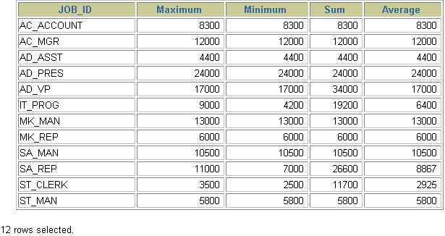
- Write a query to display the number of people with the same job.

SELECT COUNT(JOB_ID), JOB_ID FROM EMPLOYEES GROUP BY JOB_ID;

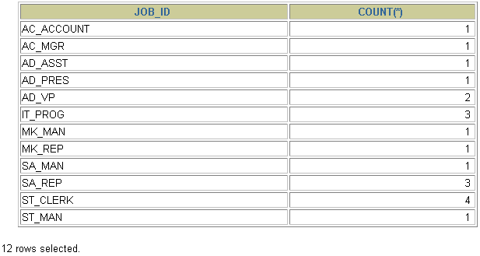
- Determine the number of managers without listing them. Label the column Number of Managers.
SELECT COUNT(DISTINCT MANAGER_ID) “Number of Managers” FROM EMPLOYEES;
8.Find the difference between the highest and lowest salaries. Label the column DIFFERENCE.
SELECT MAX(SALARY) - MIN(SALARY) DIFFERENCE FROM EMPLOYEES;

